References

1. **Journals**

Alawad, A.,Aljoufie, M., Tiwari, A., & Daghestani L. (2015). Beyond Geographical and Cultural Barriers: The Concept of a Virtual Gallery for Arts, Design & Architecture Schools in Saudi Arabia. Retrieved from Scientific Research: <https://www.scirp.org/html/1-1250089_61105.htm>

Chen, T. L., Lai, W. C., & Yu, T. K. (2021, January 11). Participating in Online Museum Communities: An Empirical Study of Taiwan’s Undergraduate Students. Frontiers in Psychology, *Volume*11, https//10.3389/fpsyg.2020.565075, ISSN=1664-1078, Retrieved May 11, 2022, from https://www.frontiersin.org/articles/10.3389/fpsyg.2020.565075/full

Chong, C., & Smith, D. (2017). Interactive Learning Units on museum websites. Journal of Museum Education, 42(2), 169–178. https://doi.org/10.1080/10598650.2017.1301626

Li J., Nie J-W, Ye J. (2022) Evaluation of virtual tour in an online museum: Exhibition of Architecture of the Forbidden City: [https://journals.plos.org/plosone/article?id=10.1371/journal.pone.0261607#sec005](https://journals.plos.org/plosone/article?id=10.1371/journal.pone.0261607" \l "sec005" \t "_blank)

Lin, M., Chen, H., & Liu, K. (2017). A Study of the Effects of Digital Learning on Learning Motivation and Learning Outcome. *Eurasia journal of mathematics, science and technology education, 13*, 3553-3564.

Madriaga, J. G., Virto, N. R., & Blaso, F. (2017, August). *The influence of museums’ websites on users’ intentions*. Retrieved from ResearchGate:https://www.researchgate.net/publication/318701715\_The\_influence\_of\_museums'\_websites\_on\_users'\_intentions

Kabassi, K. (2017). Evaluating websites of museums: State of the art. Journal of Cultural Heritage, Volume 24 - Pages 184-196.

Lopatovska, Irene. (2015). Museum website features, aesthetics, and visitors’ impressions: a case study of four museums. Museum Management and Curatorship. 30. 191-207. 10.1080/09647775.2015.1042511.

Schweibenz, Werner. (2019). The virtual museum: an overview of its origins, concepts, and terminology. 4.

Tambahani, G., Wenas, M., & Somya, R. (2016). Perancangan Online Virtual Gallery Dengan Memanfaatkan Teknologi HTML5. AITI, 13(1), 15-30. Retrieved from <https://ejournal.uksw.edu/aiti/article/view/1260>

Walsh, D., Hall, M. H., Clough, P., & Foster, J. (2020). Characterizing online museum users: a study of the National Museums. International Journal on Digital Libraries, 21:75–87.

Z. Liu, M. Wang, S. Qi and C. Yang (2019), Study on the Anti-Theft Technology of Museum Cultural Relics Based on Internet of Things: <https://ieeexplore.ieee.org/document/8788595>

1. **Electronic References**

Albadawi, Bushra Izzat (2021) “The Virtual Museum VM as a Tool for Learning Science in Informal Environment”: <https://dspace.alquds.edu/items/67d230e5-8864-4e74-b8a7-e157c33b1f24/full>

Aldrich, E., Bessette, K., Mueller, P., & Prakash, M. (2016). Evaluating Digital Learning Resources for International Students at the British Museum (Doctoral dissertation, WORCESTER POLYTECHNIC INSTITUTE).

Allen, L. B., & Crawley, K. J. (2013, November 25). *Challenging Beliefs, Practices, and Content: How Museum Educators Change*. Retrieved from Wiley Online Library:https://onlinelibrary.wiley.com/doi/10.1002/sce.21093

Anggai, S., Blekanov, I. S., & Sergeev, L. S. (2015). "Design Muntoi web-based framework and search engine analytics for thematic virtual museums,". 2015 4th International Conference on Interactive Digital Media (ICIDM), pp. 1-5, doi: 10.1109/IDM.2015.7516334.

Balanchine, S. (2018, September 29). *Museum Marketing Challenges and Solutions in Digital Transformation Era*. Retrieved from Cetrix:https://www.cetrixcloudservices.com/blog/museum-marketing-challenges-and-solutions-in-digital-transformation-era

Billock, J. (2020, September 16). *How Will Covid-19 Change the Way Museums Are Built?* Retrieved from Smithsonian:https://www.smithsonianmag.com/travel/how-will-covid-19-change-way-future-museums-are-built-180975022/

Butler, J. (2017, August 31). *Five takeaways on how museums are adapting to digital age demands*. Retrieved from Knight Foundation:<https://knightfoundation.org/articles/five-takeways-on-how-museums-are-adapting-to-digital-age-demands/>

Charr, M. (2020). *What makes a good museum website?* Retrieved from Museum Next:https://www.museumnext.com/article/what-makes-a-good-museum-website/

Chen, T. L., Lai, W. C., & Yu, T. K. (2021, January 11). Participating in Online Museum Communities: An Empirical Study of Taiwan’s Undergraduate Students. Frontiers in Psychology, Volume11, https//10.3389/fpsyg.2020.565075, ISSN=1664-1078, Retrieved May 11, 2022, from https://www.frontiersin.org/articles/10.3389/fpsyg.2020.565075/full

Cristóbal, E. F., Ramón, J. C., Daries, N., & Serra, A. C. (2021, August 20). Museums in the Digital Age: An Analysis of Online Communication and the Use of E-Commerce. Retrieved from Digital Library: <https://dl.acm.org/doi/abs/10.1145/3464977>

Fernandez, S. L., Crespo, N. T., & Fernández, R. H. (2022, January). Driving traffic to the museum: The role of the digital communication tools. *Volume*174, https://doi.org/10.1016/j.techfore.2021.121273. Retrieved from Science Direct: https://www.sciencedirect.com/science/article/abs/pii/S0040162521007071#!

Komarova, M. (2015). INTERACTIVE TECHNOLOGIES ON ART MUSEUM WEBSITES. Manhattan, Kansas, Moscow. <https://krex.k-state.edu/dspace/bitstream/handle/2097/18947/%20MariaKomarova2015.pdf?sequence=1>

Laura A. Maye, Dominique Bouchard, Gabriela Avram, and Luigina Ciolfi. 2017. r In Proceedings of the 2017 Conference on Designing Interactive Systems (DIS '17). Association for Computing Machinery, New York, NY, USA, 221–232. <https://doi.org/10.1145/3064663.3064753>

[Raimo, N.](https://www.emerald.com/insight/search?q=Nicola%20Raimo), [De Turi, I.](https://www.emerald.com/insight/search?q=Ivano%20De%20Turi), [Ricciardelli, A.](https://www.emerald.com/insight/search?q=Alessandra%20Ricciardelli" \t "_blank) and [Vitolla, F.](https://www.emerald.com/insight/search?q=Filippo%20Vitolla" \t "_blank) (2021), "Digitalization in the cultural industry: evidence from Italian museums", [International Journal of Entrepreneurial Behavior & Research](https://www.emerald.com/insight/publication/issn/1355-2554), Vol. ahead-of-print No. ahead-of-print. <https://doi.org/10.1108/IJEBR-01-2021-0082>

C. Di Stefano and F. Battisti, "Caravaggio in Rome: A qoe-based proposal for a virtual gallery," *2017 3DTV Conference: The True Vision - Capture, Transmission and Display of 3D Video (3DTV-CON)*, 2017, pp. 1-4, doi: 10.1109/3DTV.2017.8280423.

*History of Flight Booking: CRSs, GDS Distribution, Travel Agencies, and Online Reservations*. (2019, April 12). Retrieved from altexsoft: https://www.altexsoft.com/blog/travel/history-of-flight-booking-crss-gds-distribution-travel-agencies-and-online-reservations/

Ruiz, O. O. (2020, June 2). *The 10 “must-have” features of an online booking system*. Retrievedfrombookingkit:https://bookingkit.com/blog/10-must-features-online-booking-system/

Steeves, K. (2020, October 1). *What Exactly Is an Online Booking System?* Retrieved fromcheckfront:https://www.checkfront.com/blog/what-is-an-online-booking-system#:~:text=An%20online%20booking%20system%20is,operation%2C%20all%20in%20one%20place.

*THE HISTORY OF BOOKING SYSTEMS* (2021, September 15).. Retrieved from scandinaviantraveler:https://scandinaviantraveler.com/en/aviation/the-history-of-booking-systems

Appendices

Appendix A

Relevant Source Code

Appendix B

Evaluation Tool

Appendix C

Letter to the Casa Real Shrine Curator



Republic of the Philippines

Bulacan State University

##### City of Malolos, Bulacan

##### Tel (044) 919 7800 local 1101/1102

##### 

**COLLEGE OF INFORMATION AND COMMUNICATIONS TECHNOLOGY**

May 16, 2022

**MRS. MA. ANTONIA T. JIMENEZ**

Museum Curator

Casa Real Shrine

Dear Mrs. Jimenez:

Greetings!

We are 3rd-year college students from Bulacan State University taking up the course of Bachelor of Science in Information Technology. We've decided to design a website for our capstone project a VirtualShrine: An Interactive Museum website for Casa Real Shrine that will be utilized to virtualize Casa Real Shrine. As for that, we are asking for your permission to be our client on this project.

           The concept of our proposed system is to deliver more knowledge to the online museum user by improving users’ experience, interactivity, and comprehensive knowledge. This proposed project website could also serve as promotion for the Casa Real Shrine of Malolos to a vast audience online.

This system can help you on:

* Promote the Casa Real Shrine on a wider audience online.
* Online Booking Admission
* User Assisting features
* Virtual Museum tours

Students will use the information provided above for educational purposes only. We are hoping for your kind consideration and favorable response. Thank you, and God bless!

**Respectfully yours,**

**The Researchers**

**Claro, Sharvien Paul M.**

**Gabutina, Carlo Elijah R.**

**Mauricio, Angelo D.**

**Navarro, Rovi Keith Y.**

**Tapang, Jhel Ansel D.**

**Nacional, Kristine Joy S.**

Project Leader

BSIT 3M – Group 2

**Noted by:**

**Dr. Mayleen Dorcas Castro**

Capstone Coordinator

**Conforme:**

**Mrs. Ma. Antonia T. Jimenez**

Museum Curator

**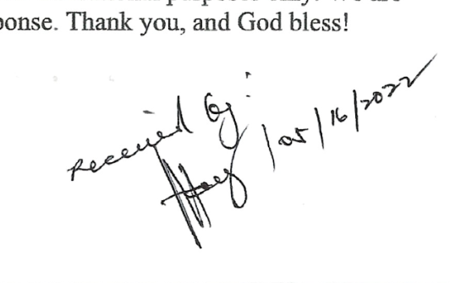**

Bulacan State University

**COLLEGE OF INFORMATION & COMMUNICATIONS**

**TECHNOLOGY**

City of Malolos 3000, Bulacan

Tel. No. (044) 796-0147/(044)791-7386

<http://www.bulsu.edu.ph/>

July 7, 2022

**MRS. MA. ANTONIA T. JIMENEZ**

Museum Curator

Casa Real Shrine

Dear Mrs. Jimenez:

Greetings!

This letter is in regard to requesting for Data collection such as images, description, and 360-degree view of the artifacts displayed in your museum. We are 3rd-year college students from Bulacan State University taking up the course of Bachelor of Science in Information Technology conducting a study entitled “VirtualShrine: an interactive website for Casa Real Shrine”.

As part of the study's development, we will photograph the artifacts on display at the museum and capture a 360-degree view of each gallery. We would also want to request a description of the artifacts that are on display.

The intention of our work is to use those data as contents for the interactive museum website for Casa Real Shrine and be able to share the collected data to the museum website visitors.

We will be very grateful to you for your help. We can assure you that your privacy will not be affected.

If you have any further queries, you can reach us at virtualshrine.developers@gmail.com

**Respectfully yours,**

**The Researchers**

**Claro, Sharvien Paul M.**

**Gabutina, Carlo Elijah R.**

**Mauricio, Angelo D.**

**Navarro, Rovi Keith Y.**

**Tapang, Jhel Ansel D.**

**Nacional, Kristine Joy S.**

Project Leader

BSIT 3M – Group 2

**Noted by:**

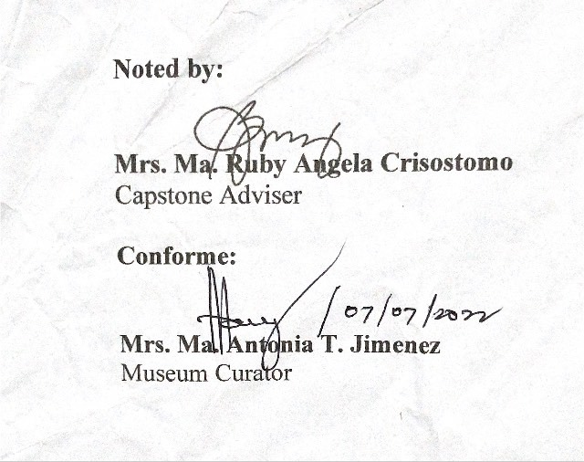

**Mrs. Ma. Ruby Angela Crisostomo**

Capstone Adviser

**Conforme:**

**Mrs. Ma. Antonia T. Jimenez**

Museum Curator

Appendix D

Request Letter for Capstone Adviser



Bulacan State University

**COLLEGE OF INFORMATION & COMMUNICATIONS**

**TECHNOLOGY**

City of Malolos 3000, Bulacan

Tel. No. (044) 796-0147/(044)791-7386

<http://www.bulsu.edu.ph/>

**MRS. MA. RUBY ANGELA CRISOSTOMO** March 31, 2022

CICT Faculty Member

Bulacan State University

Dear Mrs. Crisostomo:

Greetings!

We, the undersigned, are third year students of Bulacan State University pursuing a degree, Bachelor of Science in Information Technology and currently taking Capstone I subject.

We are writing to humbly request your service and expertise to serve as an adviser for our Capstone project. We believe that your knowledge and insights will be valuable and will greatly enrich our work.

Hoping & praying that you will consider our request. Thank you very much & God bless!

**Respectfully yours,**

The Researchers

**Claro, Sharvien Paul M.**

**Gabutina, Carlo Elijah R.**

**Mauricio, Angelo D.**

**Nacional, Kristine Joy S.**

**Navarro, Rovi Keith Y.**

**Tapang, Jhel Ansel D.**

**Noted by:**



**Dr. Mayleen Dorcas B. Castro**

Capstone Coordinator

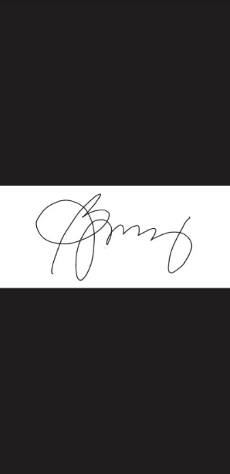**Conforme:**

**Mrs. Ma. Ruby Angela Crisostomo**

CICT, Faculty

Appendix E

Request Letter for Capstone Panels

Bulacan State University

**COLLEGE OF INFORMATION & COMMUNICATIONS**

**TECHNOLOGY**

City of Malolos 3000, Bulacan

Tel. No. (044) 796-0147/(044)791-7386

<http://www.bulsu.edu.ph/>



**MS. LILIBETH ANTONIO**  April 4, 2022

CICT Faculty Member

Bulacan State University

Dear Ms. Antonio:

Greetings!

We, the undersigned, are third year students of Bulacan State University pursuing a degree, Bachelor of Science in Information Technology and currently taking Capstone I subject.

We are writing to humbly request your service and expertise to serve as one of our panel members for our Capstone project Title Oral Presentation. We believe that your knowledge and insights will be valuable and will greatly enrich our work.

Hoping & praying that you will consider our request. Thank you very much & God bless!

**Respectfully yours,**

The Researchers

**Claro, Sharvien Paul**

**Gabutina, Carlo Elijah**

**Mauricio, Angelo**

**Nacional, Kristine Joy**

**Navarro, Rovi Keith**

**Tapang, Jhel Ansel**

**Noted by:**



**Dr. Mayleen Dorcas B. Castro**

Capstone Coordinator

**Conforme:**

**Ms. Lilibeth Antonio**

CICT, Faculty

Bulacan State University

**COLLEGE OF INFORMATION & COMMUNICATIONS**

**TECHNOLOGY**

City of Malolos 3000, Bulacan

Tel. No. (044) 796-0147/(044)791-7386

<http://www.bulsu.edu.ph/>



**ENGR. TERESITA MANGAHAS**  April 4, 2022

CICT Faculty Member

Bulacan State University

Dear Engr. Mangahas:

Greetings!

We, the undersigned, are third year students of Bulacan State University pursuing a degree, Bachelor of Science in Information Technology and currently taking Capstone I subject.

We are writing to humbly request your service and expertise to serve as one of our panel members for our Capstone project Title Oral Presentation. We believe that your knowledge and insights will be valuable and will greatly enrich our work.

Hoping & praying that you will consider our request. Thank you very much & God bless!

**Respectfully yours,**

The Researchers

**Claro, Sharvien Paul**

**Gabutina, Carlo Elijah**

**Mauricio, Angelo**

**Nacional, Kristine Joy**

**Navarro, Rovi Keith**

**Tapang, Jhel Ansel**

**Noted by:**



**Dr. Mayleen Dorcas B. Castro**

Capstone Coordinator

****

**Conforme:**

**Engr. Teresita Mangahas**

CICT, Faculty

Bulacan State University

**COLLEGE OF INFORMATION & COMMUNICATIONS**

**TECHNOLOGY**

City of Malolos 3000, Bulacan

Tel. No. (044) 796-0147/(044)791-7386

<http://www.bulsu.edu.ph/>



**MS. LYKA SAN PEDRO** April 4, 2022

CICT Faculty Member

Bulacan State University

Dear Ms. San Pedro:

Greetings!

We, the undersigned, are third year students of Bulacan State University pursuing a degree, Bachelor of Science in Information Technology and currently taking Capstone I subject.

We are writing to humbly request your service and expertise to serve as one of our panel members for our Capstone project Title Oral Presentation. We believe that your knowledge and insights will be valuable and will greatly enrich our work.

Hoping & praying that you will consider our request. Thank you very much & God bless!

**Respectfully yours,**

The Researchers

**Claro, Sharvien Paul**

**Gabutina, Carlo Elijah**

**Mauricio, Angelo**

**Nacional, Kristine Joy**

**Navarro, Rovi Keith**

**Tapang, Jhel Ansel**

**Noted by:**



**Dr. Mayleen Dorcas B. Castro**

Capstone Coordinator

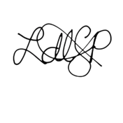

**Conforme:**

**Ms. Lyka San Pedro**

CICT, Faculty

Appendix F

User Manual

**CASA REAL SHRINE MUSEUM**

**User’s Manual**

This document was created prior to the use of the VirtualShrine Content Management System. This Document has been issued to the Curator of the Museum as for their reference regarding the use and procedures of reservation of the VirtualShrine Content Management System.

**The Front Office:**

Description: The front office is where the visitors can view the features of the VirtualShrine Website. Navigate the Museum using the navigation features of the system. The Visitor can also make booking anytime of the day.

To access the front office kindly visit http://virtualshrine.online, the home page of the website will appear.

**The Homepage**

The homepage is the main portal to the entire website. It creates the first impression for visitors and quickly comes to represent the museum to its online audience

**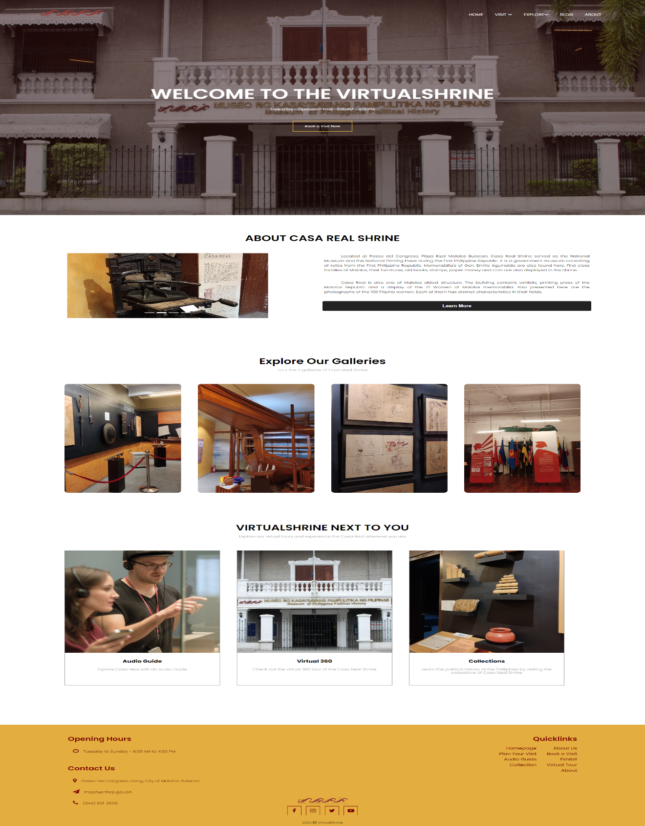**

**The Homepage Header**

The website header is where the navigation tags, book now button, and website logo are located. The navigation tags are located on the top of the header where it is aligned with the logo. The header also provides quick access to the booking form.

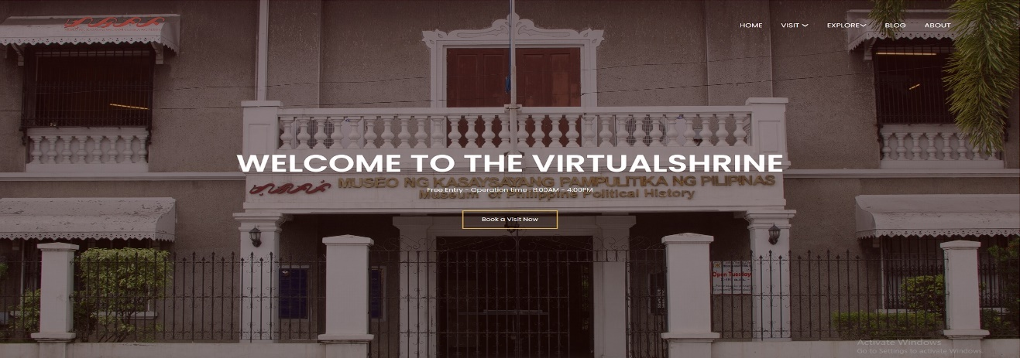

**The Homepage Contents**

This section displays the highlight features of the website.

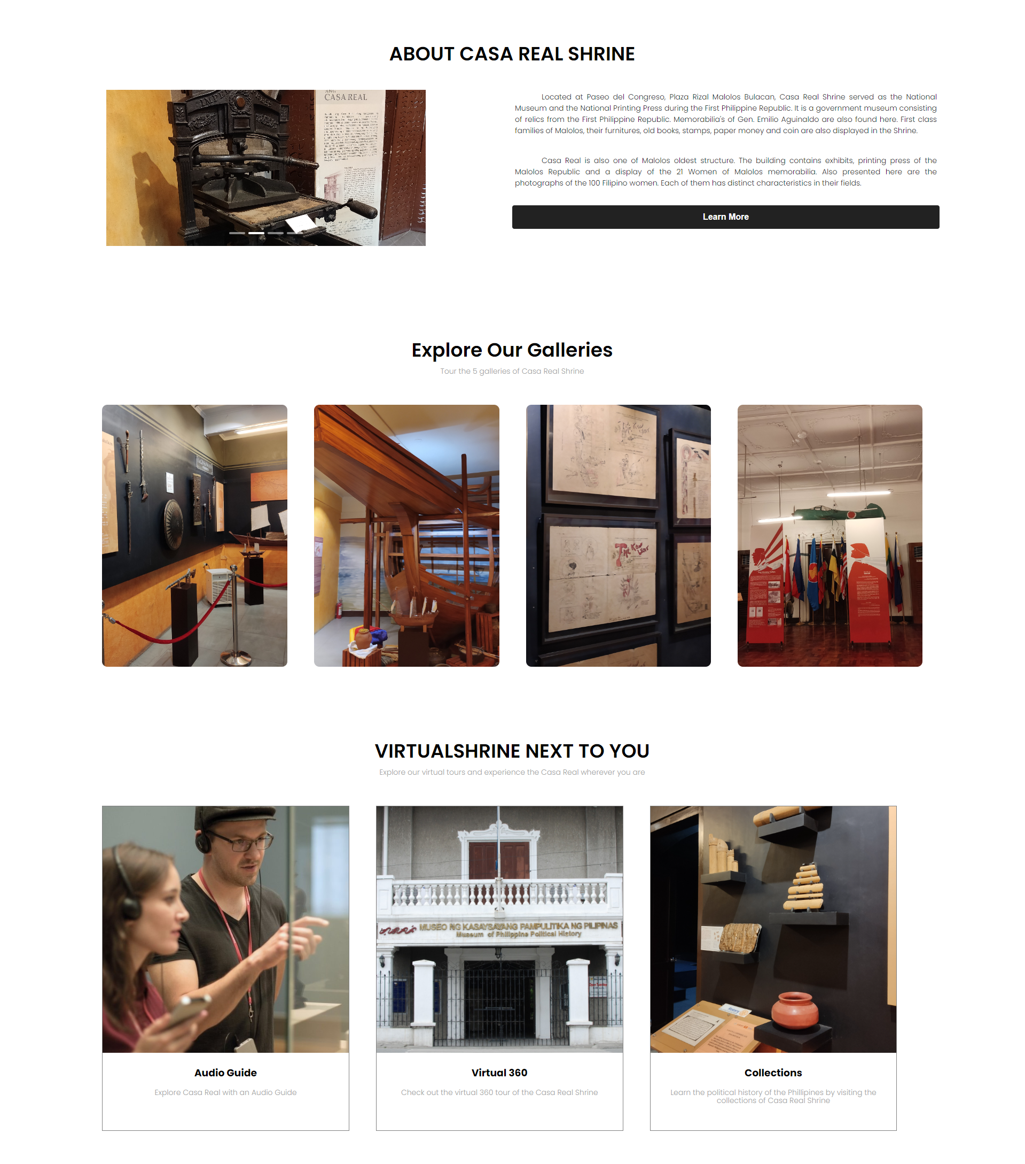

**The Homepage Footer**

This section displays the general information about the museum such as contact information, and social media quick links that can redirect the visitor to the social media accounts of the museum.

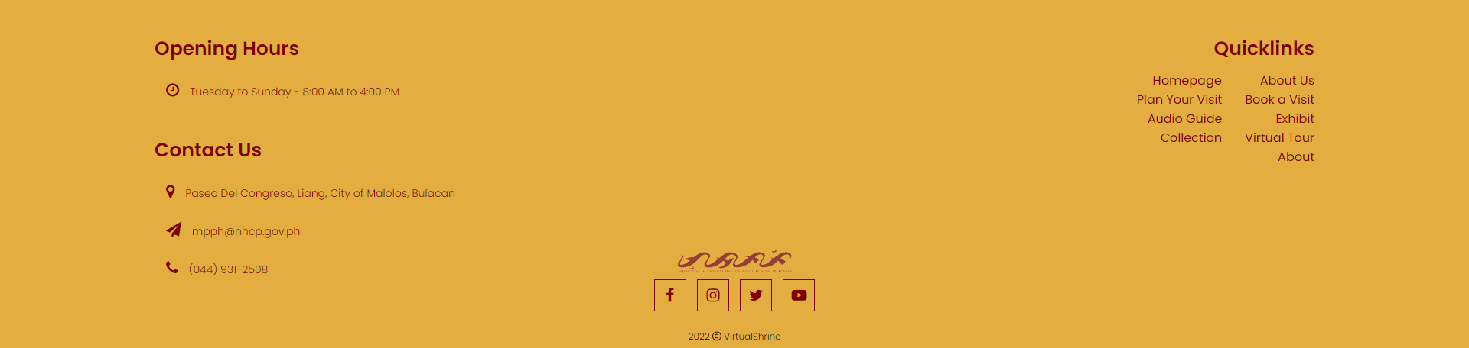

**Booking Consent Form**

This process allows the visitor to read and understand that the booking process will require the visitor to provide sensitive information. This serves as an agreement between the Visitor and the Museum.

**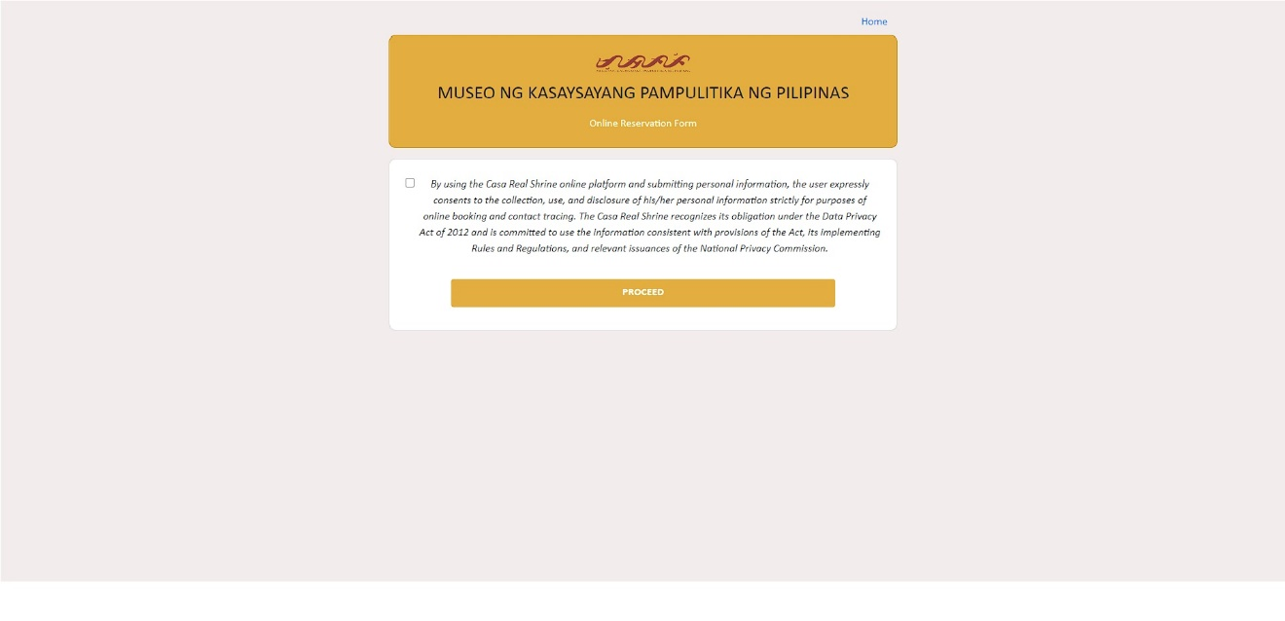**

**The Online Booking Process**

This page is where the reservation process is done. The labels with red asterisk(\*) means that the information is required and visitor will not be able to proceed without providing the required information.

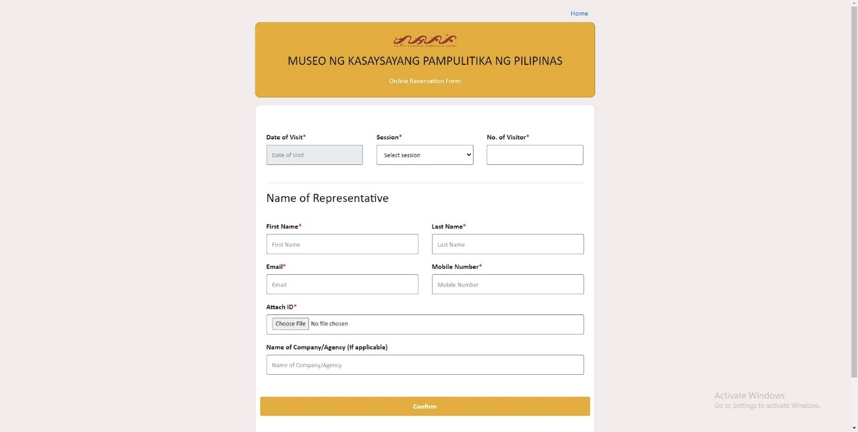

1. **Enter the Schedule of the visit**

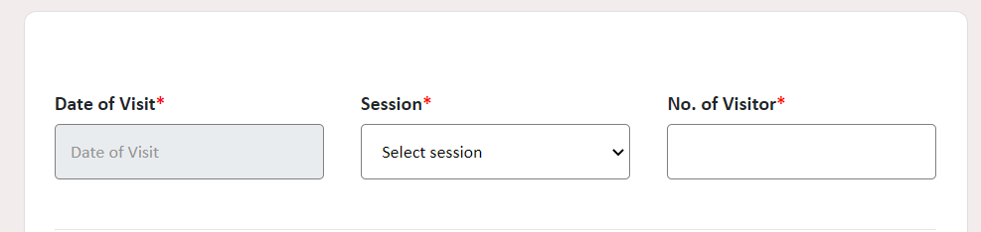This section in the booking form is where the visitor can provide the booking schedule information they want.

**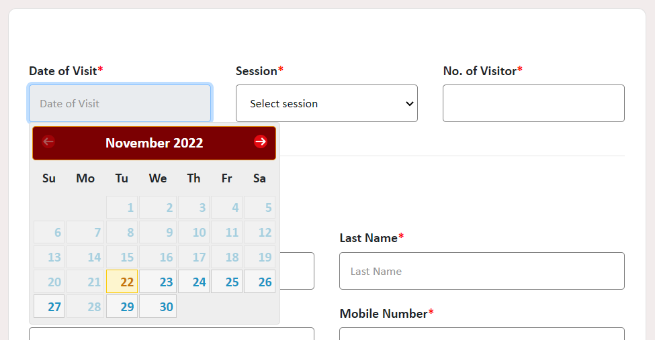**

* 1. **Select a Date**

It allows the visitor to select the date of visit. The calendar also automatically disables the dates that have already passed, as well as the dates every Monday because the museum is closed.

**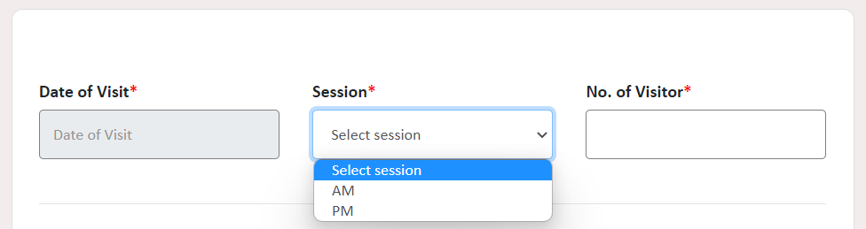**

* 1. **Select Session**

The visitor can select the session of their visit.

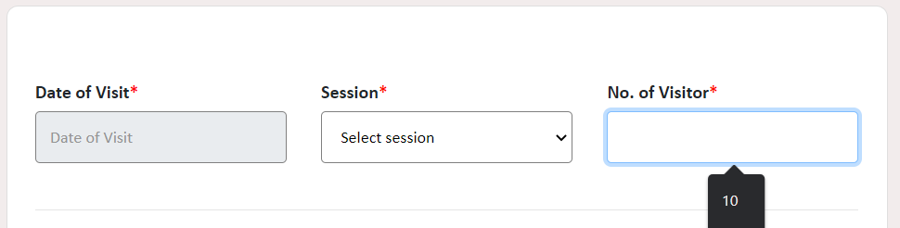

* 1. **Enter Number of Visitor**

This is where the visitor can enter the number of visitors.

1. **Enter Visitor/Representative Information**

This section of the booking form is where the visitor will enter the required information. The following information is needed for communication, and identity verification process.

**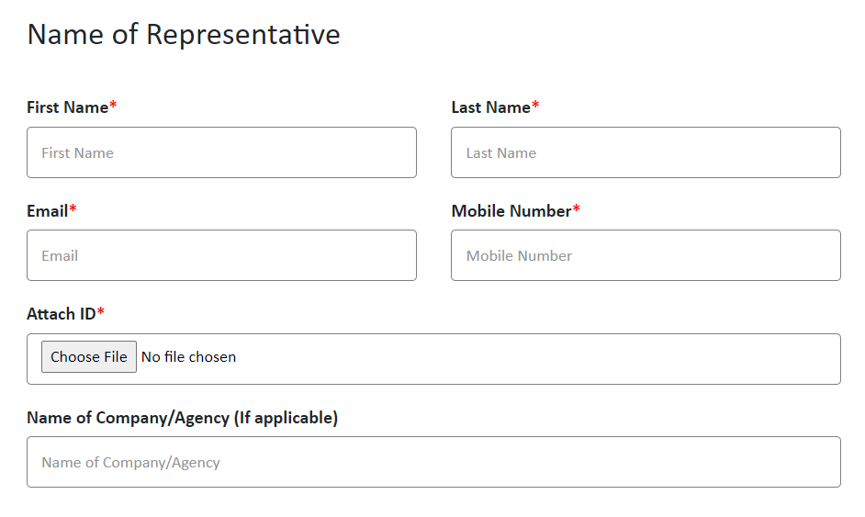**

**2.1 Enter First Name, Last Name, Email, Mobile Number of Visitor**

This is where the user will enter some of the information that the booking form asking like First Name, Last Name, Email and Mobile Number

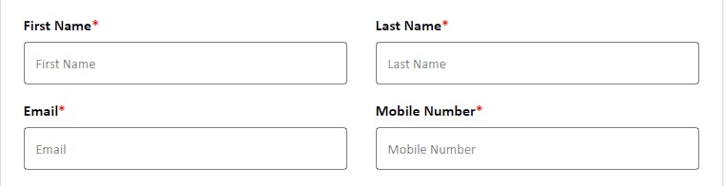

**2.2 Uploading Valid ID**

The Visitor will upload a picture or their valid ID by clicking Choose File.

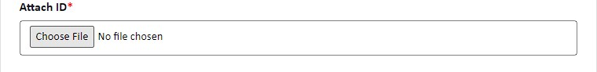

**The Back Office: [Currently under debugging process]**

**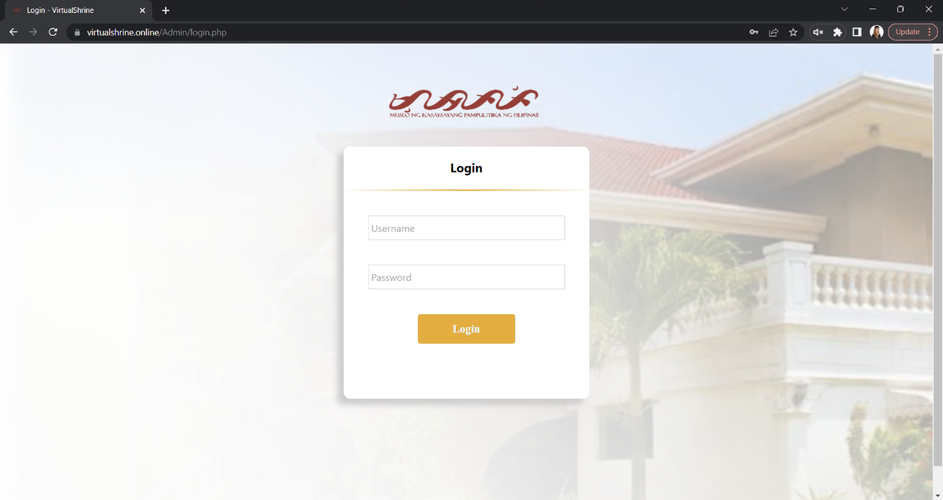**

Curriculum Vitae

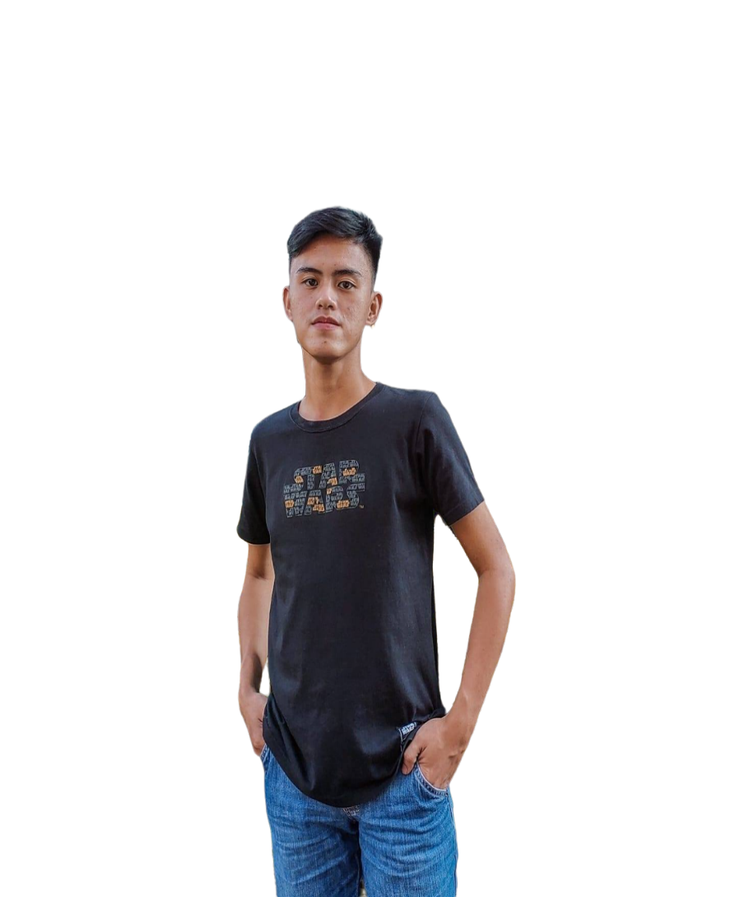

**Sharvien Paul M. Claro**

Borol 2nd Balagtas Bulacan

09062698915

sharvienpaul.claro.m@bulsu.edu.ph

**EDUCATIONAL BACKGROUND:**

**TERTIARY** Bulacan State University (Main Campus)

**EDUCATION:** Malolos, Bulacan

2019 – Present

**HIGHER SECONDARY** Dr. Yanga’s College INC

**EDUCATION:** 182 MacArthur Hwy, Bocaue, 3018 Bulacan 2017 – 2019

**LOWER SECONDARY** Balagtas National Agricultural High School

**EDUCATION:** Pulong Gubat, Balagtas, 3018 Bulacan, Philippines. 2013 – 2017

**PRIMARY:** ABACADA International School

Balagtas, Bulacan

2007 – 2013

**HONORS AND AWARDS:**

HIGHER SECONDARY EDUCATION:

* With Honors

TERTIARY EDUCATION:

* Dean’s List

**TRAININGS/SEMINARS ATTENDED:**

* StackLeague University Series: Bulacan State University Edition (2022)

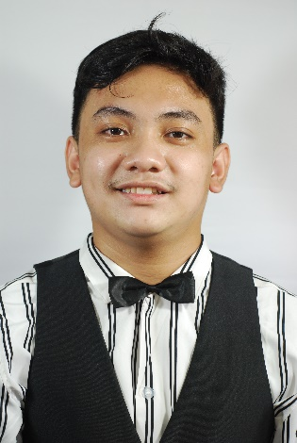

**Carlo Elijah R. Gabutina**

#30 Kilowatt, Meralco Village, Lias Marilao Bulacan

09092065191

carloelijah.gabutina.r@bulsu.edu.ph

**EDUCATIONAL BACKGROUND:**

**TERTIARY** Bulacan State University (Main Campus)

**EDUCATION:** Malolos, Bulacan

2018 – Present

**HIGHER SECONDARY** ACLC College of Meycauayan

**EDUCATION:** MC Mall Building, McArthur Hi-way Banga Meycauayan 2016 – 2018

**LOWER SECONDARY** Barcelona Academy

**EDUCATION:** 35, Lias Road, Marilao, 3019 Bulacan

2012 – 2016

**PRIMARY:** Barcelona Academy

35, Lias Road, Marilao, 3019 Bulacan

2006 – 2012

**TRAININGS/SEMINARS ATTENDED:**

* StackLeague University Series: Bulacan State University Edition (2022)

**WORK EXPERIENCE:**

* Work Immersion
* Assistant to the supervisor in ACLC

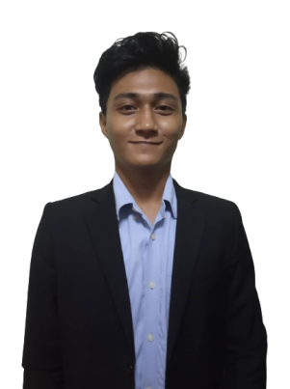

**Angelo D. Mauricio**

164 Agoncillo Street Ana Maria Village Iba Meycauayan Bulacan

09756759366

angelo.mauricio.d@bulsu.edu.ph

**EDUCATIONAL BACKGROUND:**

**TERTIARY** Bulacan State University (Main Campus)

**EDUCATION:** Malolos, Bulacan

2019 – Present

**HIGHER SECONDARY** ACLC College of Meycauayan

**EDUCATION:** MC Mall Building, McArthur Hi-way Banga Meycauayan 2017 – 2019

**LOWER SECONDARY** A.F.G. Bernardino Memorial Trade School

**EDUCATION:** Lias Rd, Lias, Marilao, Bulacan 2013 – 2017

**PRIMARY:** Trinitas College

Pantoc Rd, Meycauayan, Bulacan

2007 – 2013

**HONORS AND AWARDS:**

HIGHER SECONDARY EDUCATION:

* With Honors (Senior High School)

TERTIARY EDUCATION:

* Dean’s List

**TRAININGS/SEMINARS ATTENDED:**

* IT week seminars
* StackLeague University Series: Bulacan State University Edition (2022)

**WORK EXPERIENCE:**

* Work Immersion

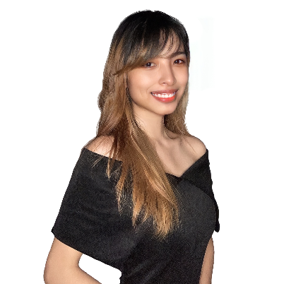

**Kristine Joy S. Nacional**

Block 9 Lot 18, Galas Street, Bignay, Valenzuela City

09361685997

kristinejoy.nacional.s@bulsu.edu.ph

**EDUCATIONAL BACKGROUND:**

**TERTIARY** Bulacan State University (Main Campus)

**EDUCATION:** Malolos, Bulacan

2019 – Present

**HIGHER SECONDARY** ACLC College of Meycauayan

**EDUCATION:** MC Mall Building, McArthur Hi-way Banga Meycauayan 2017 – 2019

**LOWER SECONDARY** Antique National School

**EDUCATION:** Tobias A. Fornier Street, San Jose de Buenavista, Antique 2013 – 2017

**PRIMARY:** Malandog Elementary School

Malandog Hamtic Antique

2007 – 2013

**HONORS AND AWARDS:**

PRIMARY:

* Class Valedictorian (Class 2012 – 2013)

HIGHER SECONDARY EDUCATION:

* With Honors (Grade 11)
* With High Honors (Grade 12)

TERTIARY EDUCATION:

* Dean’s List

**TRAININGS/SEMINARS ATTENDED:**

* StackLeague University Series: Bulacan State University Edition (2022)

**WORK EXPERIENCE:**

* Special Program of the Employment of Students (SPES) - 2015
* Work Immersion

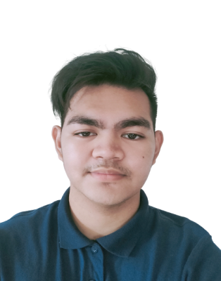

**Rovi Keith Y. Navarro**

165 Purok Rosal Caduang Tete Macabebe Pampanga

09612947453

rovikeithn@gmail.com

**EDUCATIONAL BACKGROUND:**

**TERTIARY** Bulacan State University (Main Campus)

**EDUCATION:** Malolos, Bulacan

2019 – Present

**HIGHER SECONDARY** Pampanga Colleges

**EDUCATION:** Poblacion Macabebe Pampanga 2017 – 2019

**LOWER SECONDARY** Caduang Tete High School

**EDUCATION:** Purok Rosal Caduang Tete Macabebe Pampanga 2013 – 2017

**PRIMARY:** Caduang Tete Elementary School

Centro Caduang Tete Macabebe Pampanga

2007 – 2013

**HONORS AND AWARDS:**

HIGHER SECONDARY EDUCATION:

* With Honors (Senior High School)

**TRAININGS/SEMINARS ATTENDED:**

* IT week seminars
* StackLeague University Series: Bulacan State University Edition (2022)
* Research seminar in Pampanga Colleges

**WORK EXPERIENCE:**

* Work Immersion
* Assistance to the Administrator in STI

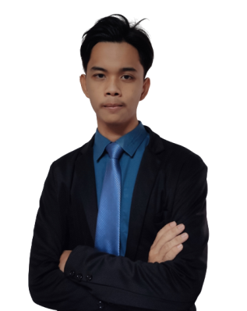

**Jhel Ansel D. Tapang**

05-B Purok 1 Lugam Malolos Bulacan

09125216212

jhelansel.tapang.d@bulsu.edu.ph

**EDUCATIONAL BACKGROUND:**

**TERTIARY** Bulacan State University (Main Campus)

**EDUCATION:** Malolos, Bulacan

2019 – Present

**HIGHER SECONDARY** La Consolacion University Philippines

**EDUCATION:** Bulihan Malolos Bulacan

2017 – 2019

**LOWER SECONDARY** Dampol 1st National High School

**EDUCATION:** Dampol Plaridel Bulacan

2013 – 2017

**PRIMARY:** Santisima Trinidad Elementary School

Santisima Malolos Bulacan

2007 – 2013

**HONORS AND AWARDS:**

HIGHER SECONDARY EDUCATION:

* With Honors (Junior High School)

**TRAININGS/SEMINARS ATTENDED:**

* CICT Week
* IT Week Seminar
* StackLeague University Series: Bulacan State University Edition (2022)

**WORK EXPERIENCE:**

* Work Immersion